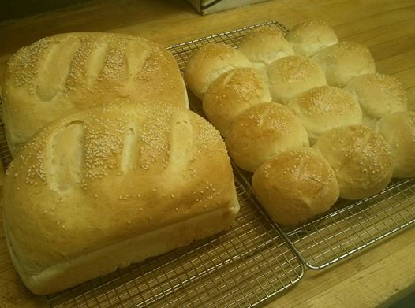
Weekly Menu
Feb 10-Feb 16

We accept all major credit cards.
Home Style Takeout and Catering

Your home comfort food while away from home.
Hours
6:30 A.M. – 7:00 P.M.

18 Koihok-Maghagak Rd.
Phone (867) 983-2067

e-mail – catering@qillaq.ca
Owned and Operated by:
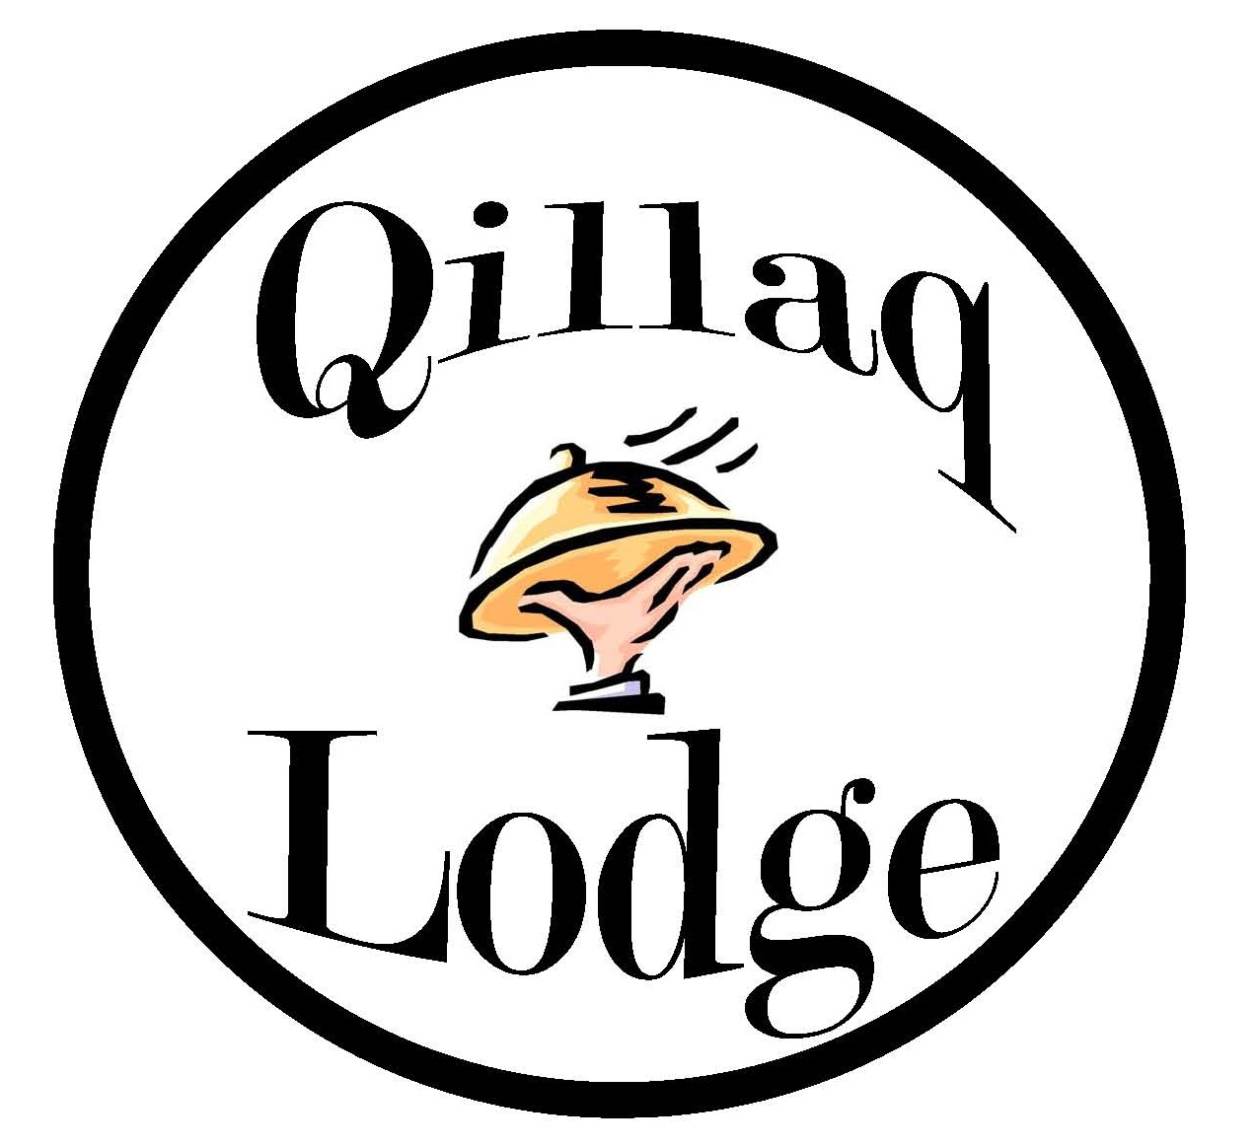
Qillaq Lodge
Saturday Feb 10
Lunch
Perogies with smokies, hearty tomato soup
And dessert. $20.00

Supper  NY steak, Cajun butter prawns, baked  Potato, fresh broccoli, salad and dessert. | $45.00
Sunday Feb 11

Lunch
Mexican pasta, crispy chicken Cesar wrap, cream of
Vegetable soup and dessert. $25.00

Supper
Carved roast beef, yorkies, gravy, mashed
Potato, buttered green peas, salad and dessert. $40.00
Monday Feb 12
*Bannock Monday!
$2.00 each or 12/$20.00
Lunch  Grilled ham and cheese sandwich, beef vegetable  Soup and dessert, | $20.00
Supper  Spaghetti and meatballs, garlic toast, Cesar salad and dessert. | $35.00

Tuesday Feb 13
*2 for 1 Personal size pan Pizza!
*Buy 2 Personal size pepperoni pizzas
For the price of 1 Pizza - $20.00
Lunch  Baked ham mac and cheese, deli meat croissant,  Chicken noodle soup and dessert. | $25.00
Supper  Fish and Chips, salad and dessert. | $35.00

Wednesday Feb 14  *Fresh Bread Day!  $10.00 a loaf  $15.00/ 12 buns  Lunch  BLT on fresh bread, bean and bacon soup and dessert. | $20.00
Supper  Salsa Chicken, basmati rice, glazed carrots, salad and dessert. | $35.00
Thursday Feb 15
* Cookies Galore
12 cookies for $10.00
Lunch  Chicken or beef Mexican tater tots, cream of mushroom soup and dessert. | $20.00
Supper  Carved Ham, roasted potato, buttered peas and carrots, salad and dessert. | $40.00
Friday Feb 16

Lunch
Loaded beef burger, poutine, French onion soup
And dessert. $25.00

Supper

Pizza – Personal Size Pan $20.00

- Family Size Pan $35.00

Selections:

Pepperoni, Hawaiian, All Dressed and Meat lovers

