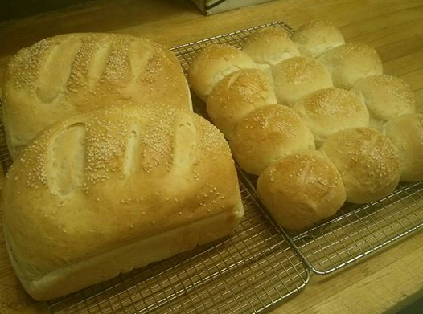
Weekly Menu
Feb 3-Feb 9

We accept all major credit cards.
Home Style Takeout and Catering

Your home comfort food while away from home.
Hours
6:30 A.M. – 7:00 P.M.

18 Koihok-Maghagak Rd.
Phone (867) 983-2067

e-mail – catering@qillaq.ca
Owned and Operated by:
Qillaq Lodge
Saturday Feb 3
Lunch
Chicken or beef Mexican tater tots,
Cream of mushroom soup and dessert $20.00

Supper  NY steak, steamed mussels in marinara, baked  Potato, fresh broccoli, salad and dessert. | $45.00
Sunday Feb 4
Sunday Brunch 10am-2pm
Breakfast Buffet- Eggs benedict, French toast,
Pancakes, bacon, sausage, hash browns, etc.
Adult $30.00
Children (10 and under) $10.00

Supper
**SUPER BOWL SUNDAY** $40.00
Chicken wings, mozza sticks, French fries and
Chili cheese nachos
Monday Feb 5
*Bannock Monday!
$2.00 each or 12/$20.00
Lunch  Chili, rice, bannock, cream of broccoli soup and  Dessert. | $25.00
Supper  Carved glazed ham, scalloped potato, buttered  Peas and carrots, salad and dessert. | $40.00

Tuesday Feb 6
*2 for 1 Personal size pan Pizza!
*Buy 2 Personal size pepperoni pizzas
For the price of 1 Pizza - $20.00
Lunch  Chicken fingers, fries, chicken vegetable soup and  Dessert. | $20.00
Supper  Teriyaki beef stirfry, rice and roasted cauliflour. | $35.00

Wednesday Feb 7  *Fresh Bread Day!  $10.00 a loaf  $15.00/ 12 buns  Lunch  BLT on fresh bread, baked mac and cheese, bean and bacon soup and dessert. | $20.00
Supper  Citrus chicken drumsticks, battered cod, roasted potato, fresh vegetable medley, salad and dessert. | $35.00
Thursday Feb 8
* Cookies Galore
12 cookies for $10.00
Lunch  Ham, turkey and Swiss Monte cristo, hearty tomato vegetable soup and dessert. | $20.00
Supper  BBQ pork ribs, Cajun potato wedges, buttered kernel corn, salad and dessert. | $40.00
Friday Feb 9

Lunch
Donairs, fries, potato bacon soup and dessert. $20.00

Supper

Pizza – Personal Size Pan $20.00

- Family Size Pan $35.00

Selections:

Pepperoni, Hawaiian, All Dressed and Meat lovers

